🧩 MONIK GROUP ERP – UI DESIGN (VISUAL STRUCTURE)

🖥️ 1. MAIN DASHBOARD (CEO / HEAD OFFICE VIEW)
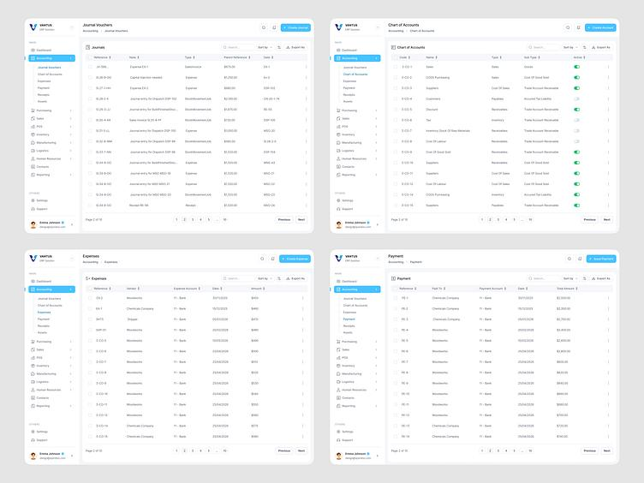
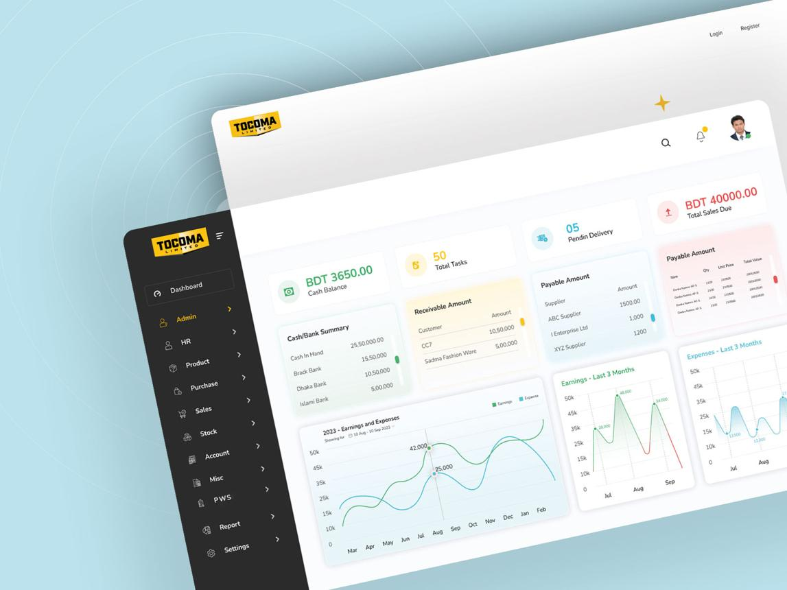
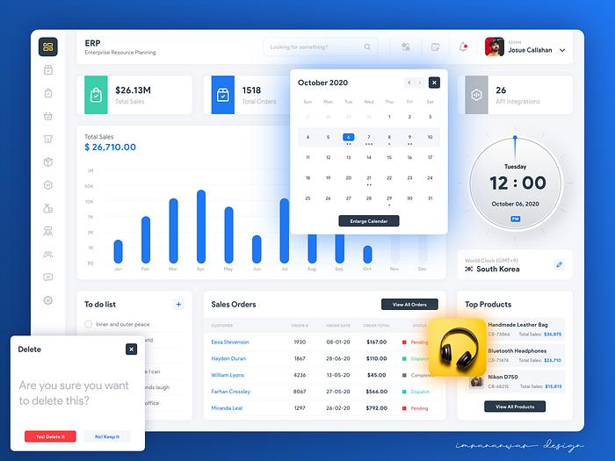
7
🔷 Layout Structure
🔝 Top Bar
- Logo (Monik Group)
- User Profile
- Notifications 🔔
- Quick Actions (+ Add Asset / + Create Ticket)

📊 KPI CARDS (Top Row)
- Total Branches
- Total Assets
- Open Service Issues
- Average Audit Score

📈 Charts Section
- Branch Performance (Bar Chart)
- Region Comparison (Pie Chart)
- Audit Trend (Line Chart)

🚨 Alerts Panel
- Low score branches
- Overdue service tickets
- Asset issues

🏢 2. BRANCH MANAGEMENT SCREEN
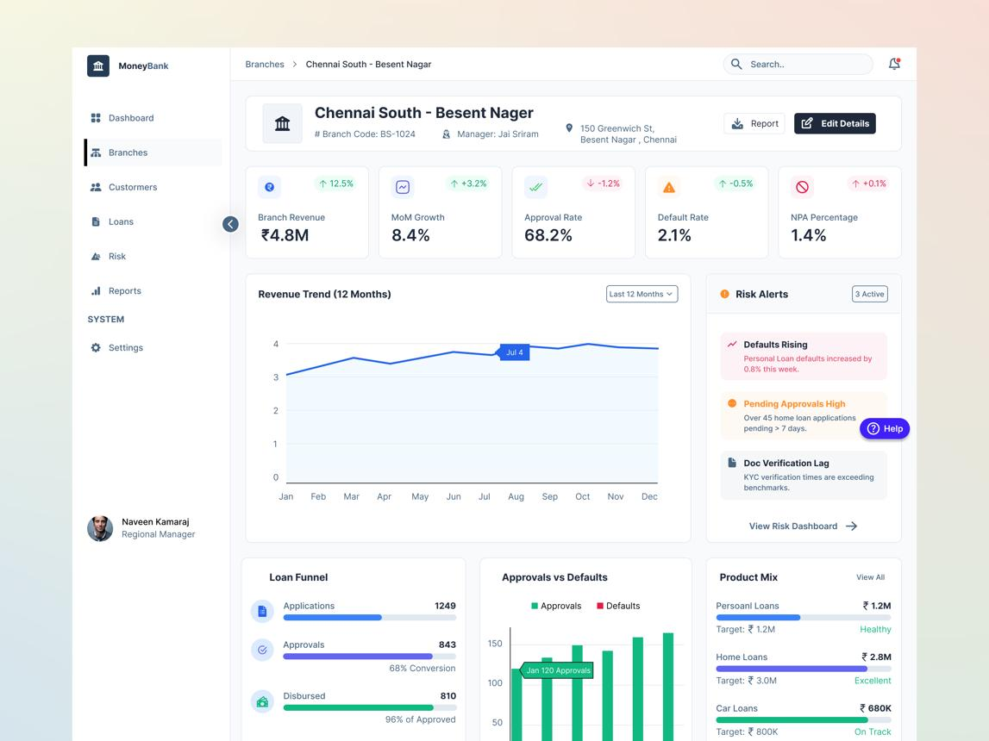
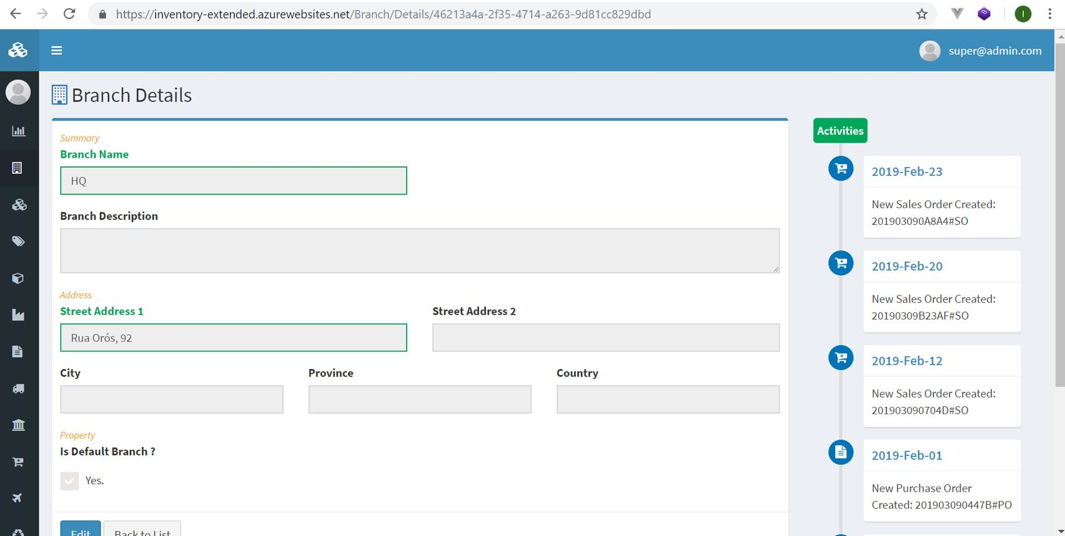
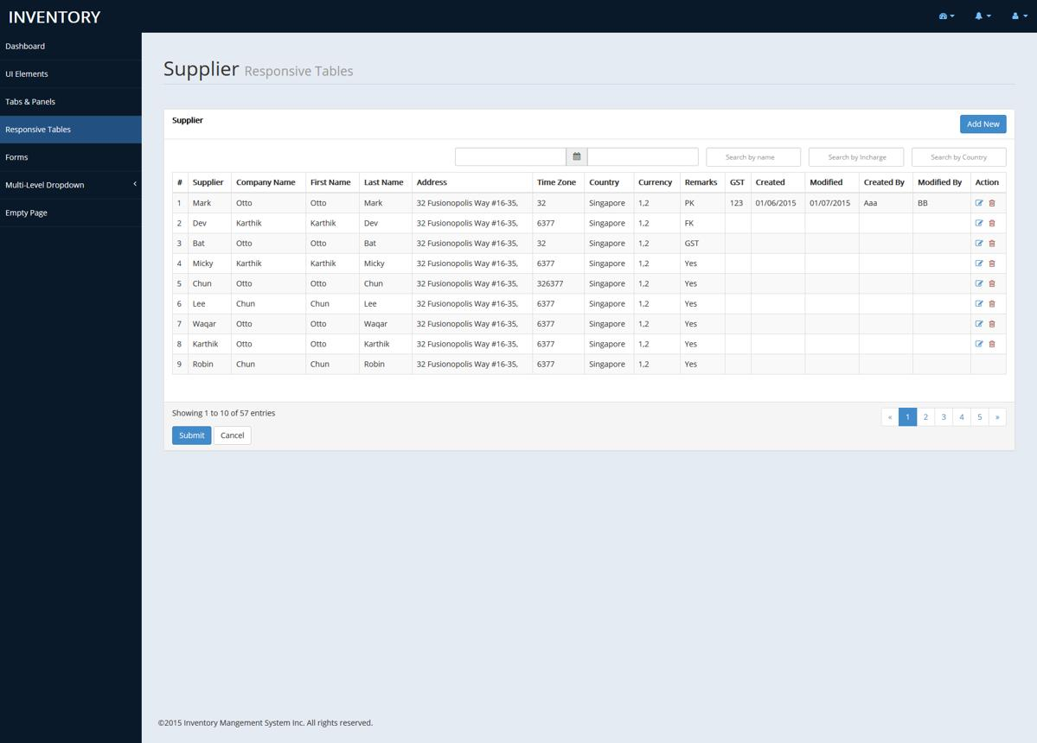
5
🔷 Features
🔍 Filters:
- Region
- Company
- Status
📋 Table:
| Branch ID | Name | Region | Company | Status | Actions |
⚙️ Actions:
- View
- Edit
- Disable

➕ Add Branch Form
Fields:
- Branch Name
- Company
- Region
- Opening Date

📦 3. ASSET MANAGEMENT SCREEN
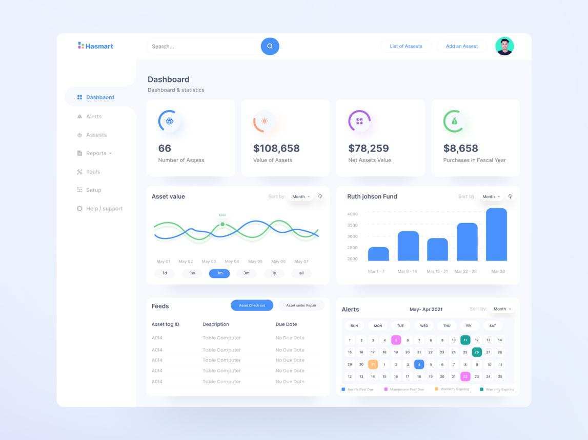
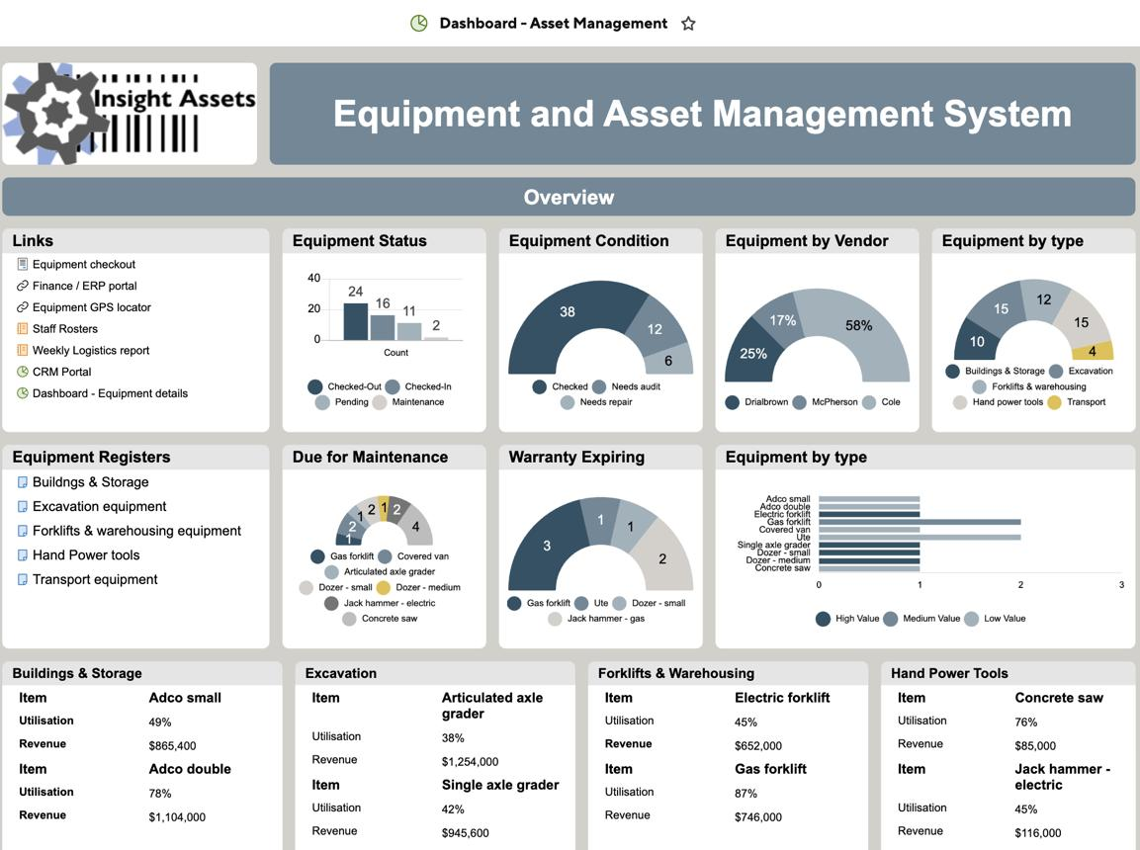
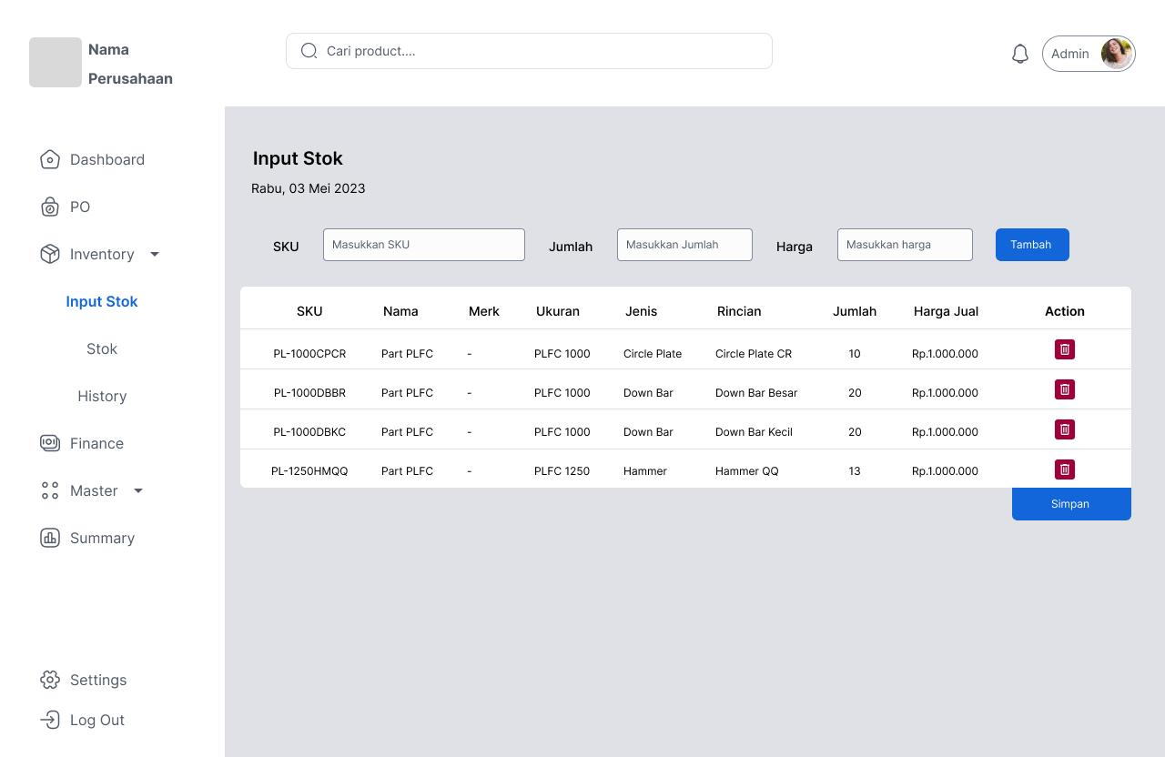
8
🔷 Table View
| Asset ID | Name | Category | Branch | Status | QR | Actions |

🔷 Key Buttons:
- ➕ Add Asset
- 🔄 Transfer Asset
- 🖨️ Print QR

🔷 Asset Detail Page
- Asset Info
- QR Code (display)
- History log
- Service history

🔧 4. SERVICE & MAINTENANCE MODULE
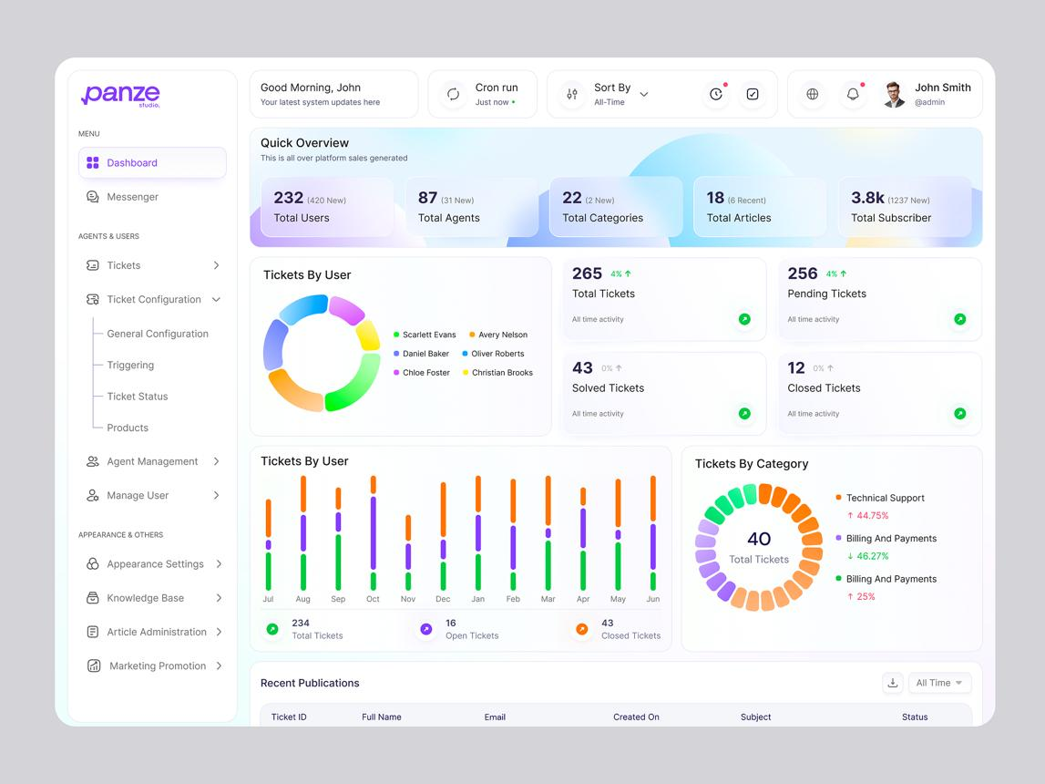
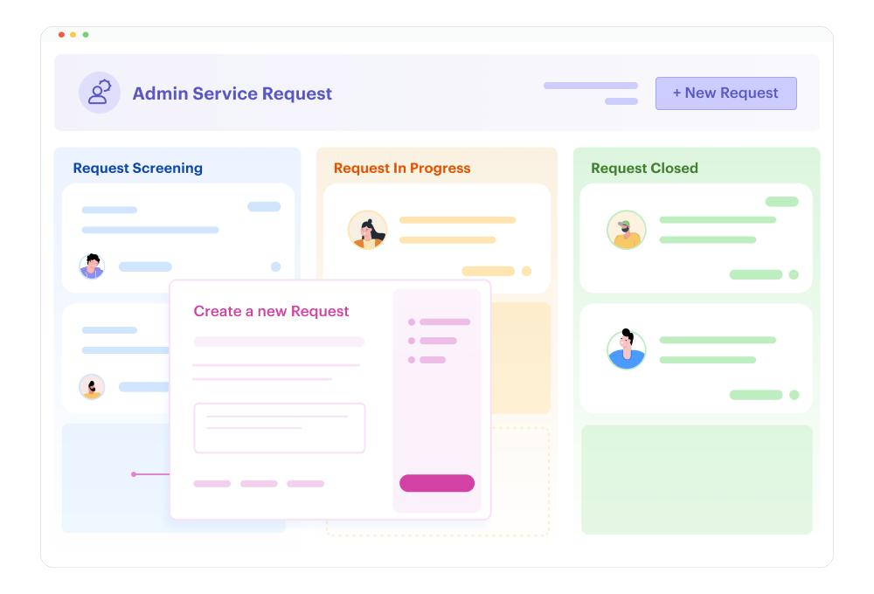
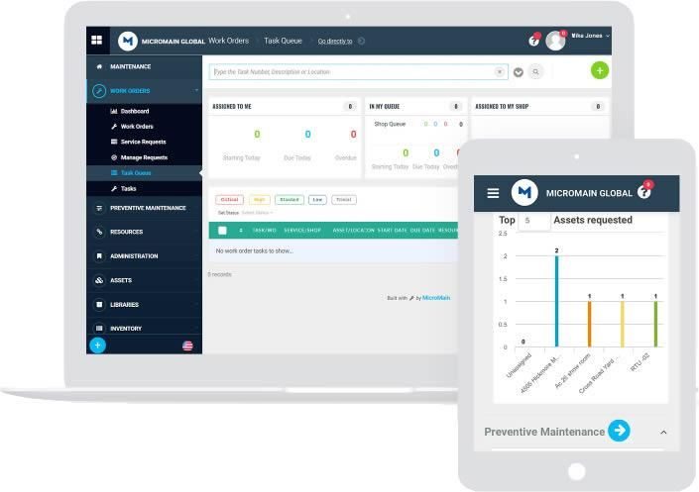
7
🔷 Ticket Board (Kanban Style)
Columns:
- New
- In Progress
- Completed

🔷 Ticket Fields:
- Asset ID
- Issue
- Assigned Technician
- Priority
- Status

📊 5. AUDIT & COMPLIANCE DASHBOARD
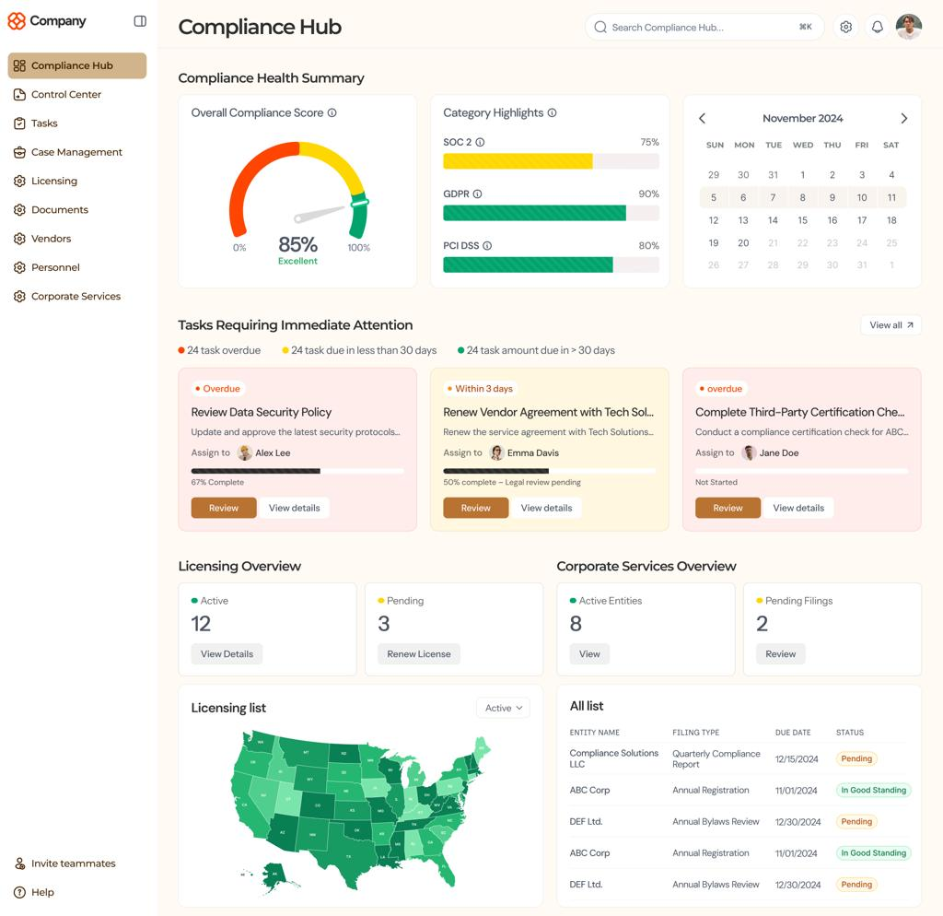
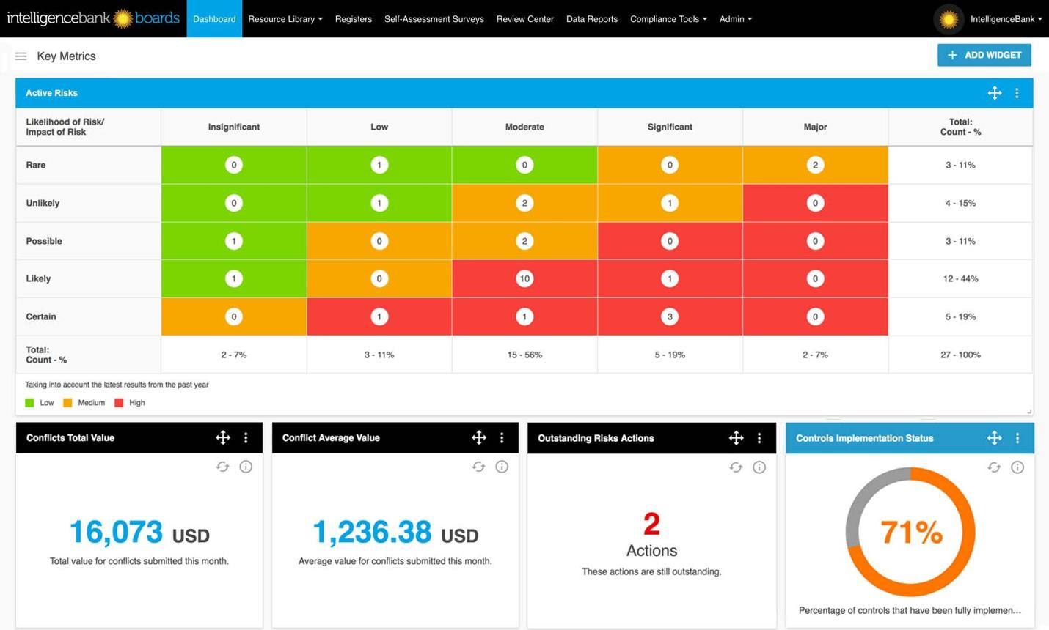
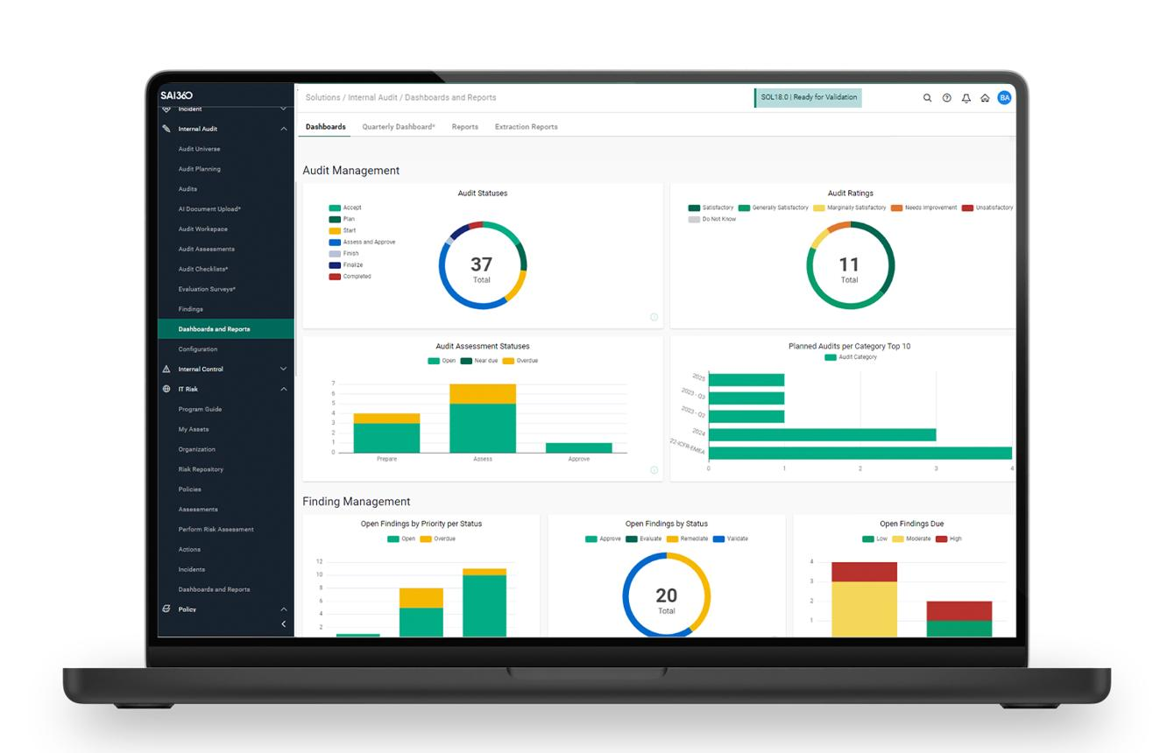
6
🔷 Features
📊 Score Table:
| Branch | Score | Status |

🎯 Visual Indicators:
- Green (>80)
- Yellow (60–80)
- Red (<60)

📍 Map View (Optional Upgrade)
- Branches by risk level

📁 6. DOCUMENT MANAGEMENT SYSTEM (DMS)
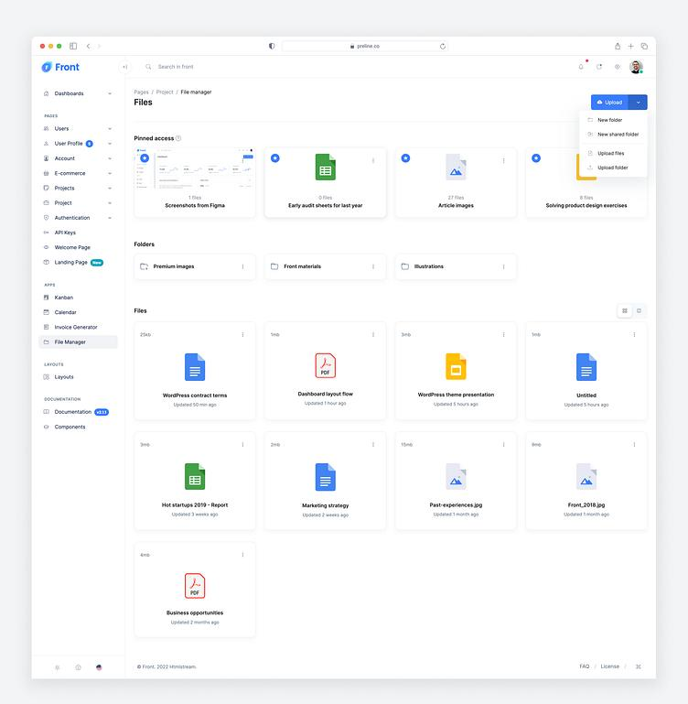
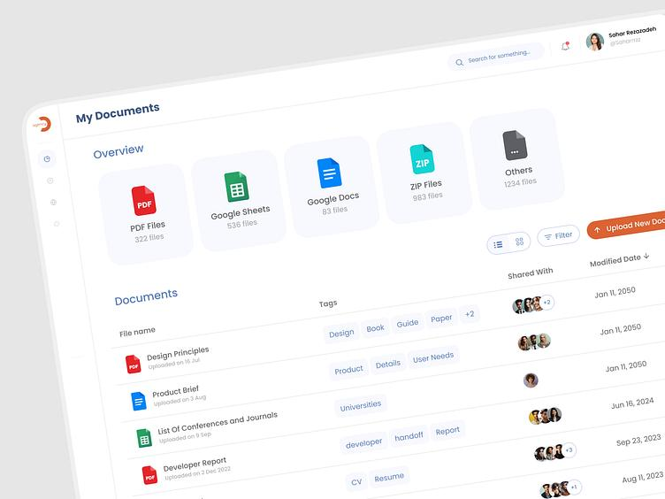
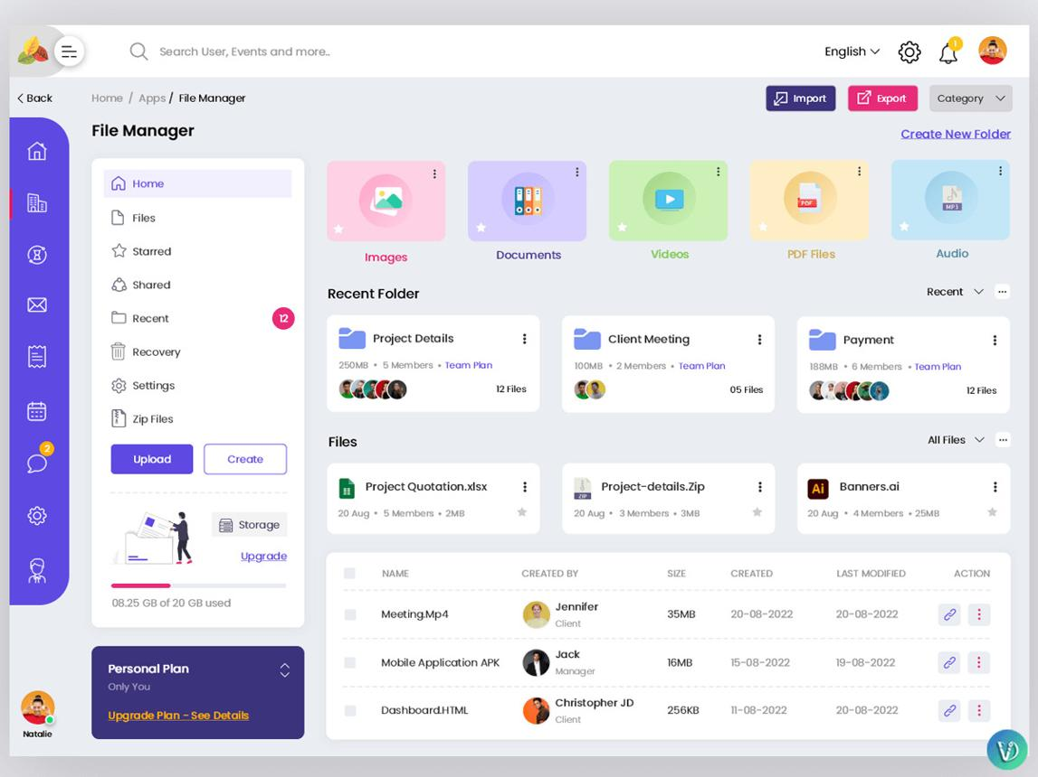
7
🔷 Features
- Upload documents
- Folder structure (Branch / Legal / Contracts)
- Version history
- Expiry alerts

👥 7. USER MANAGEMENT SCREEN
🔷 Roles:
- Admin
- Regional Manager
- Branch Manager
- Auditor
- Technician

🔷 Table:
| Name | Role | Branch | Status |

🔐 8. LOGIN PAGE
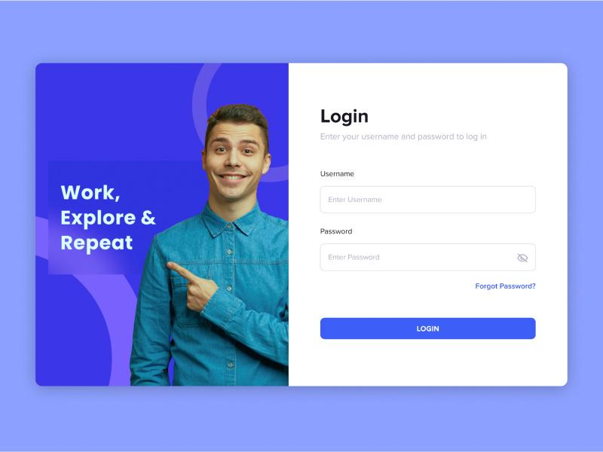
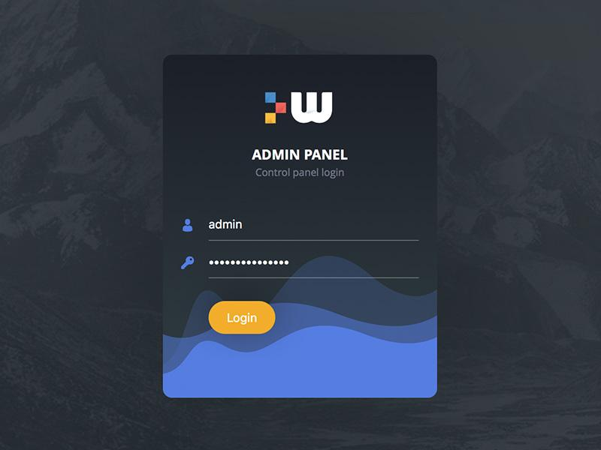
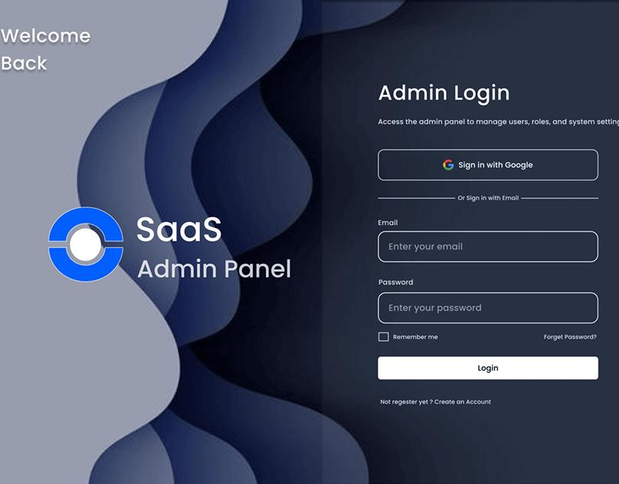
6
🔷 Features
- Username / Password
- Role-based access
- Forgot password

🔥 SYSTEM FLOW (VERY IMPORTANT)
Login → Dashboard → Module Selection
↓
Branches ↔ Assets ↔ Services ↔ Audits ↔ Documents

⚠️ CRITICAL DESIGN RULES (DON’T IGNORE)
- Keep UI simple and fast
- Avoid too many fields
- Mobile-friendly (very important for audits)
- Role-based access (finance vs others)

🚀 WHAT YOU SHOULD DO NEXT
Now you have clear UI screens, next step is:
👉 Option 1 (Recommended)
I design:
- Full clickable wireframe (Figma-style)
- Ready for developers
👉 Option 2
I create:
- Database + API structure
- So your developer can start coding immediately
👉 Option 3
I build:
- Complete system flow document (SRS)
→ This is what professional IT teams use

Just tell me:
👉 “Create Figma wireframe”
👉 “Create database + API design”
👉 “Create full SRS document”
I’ll take you to the next level.

